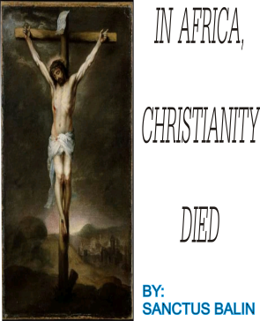
CONTENTS
- Christianity overview in Africa
- Christianity in the Recent Times
- What Christianity Demands from us (Christians).
- What the Church demands from Us (Christians).
- What Christians Demands from Christianity
- What Recent Christians Demands from the Church and Christianity
- Reflections

PHASE ONE

Christianity overview in Africa
Christianity in Africa arrived from Egypt in the middle of the 1st century, it encompasses various and countries in across the whole of Africa. It is understood that it the lawful teaching and doctrines of the Christian religion which proceeded from our lord Jesus Christ. Over the years, it was confirmed that Christian religion has gone virtually the confines of Africa and its environs. It has been the pure relationship with God based on faith and cordial relationship between God and man. Christians makes use of THE HOLY BIBLE, and other books of doctrines and dogma.
But in the recent times, things has metamorphosed to what man cannot comprehend, which causes the major bane in our society, the major aim of the circulation of the religion has been ridiculed and brought the mud.
Generally, it was believed that the existence of Christianity religion would bring to normalcy to the ill and evil of the community and recent times, but the reverse is consequently the case.

Christianity in the Recent Times
The recent thrill of the Christianity in Africa cannot be over emphasized; it is doing the nation more harm than good. Basically, it has contributed more problems than the good virtues it supposed to portray. The over spread of many denominations across the spheres of Africa causes stir in the projection of the real objective of the religion.
Much harm has been caused, much fake proclamation has been made, and many evil bounds has been created, much vacuum has been created between FAITH, GODLINIESS, and CHRISTINAITY. In this recent scenario, many have become self made and acclaimed men of God and pastors, many practically sleeps in churches, ministries and prayer houses, many sells off their properties due to prophecies, to feed pastors, and many practically worships the pastors, pastors wives instead of the main objective of the establishment of the RELIGION.
Many atrocities accompanies the recent Christian religion in this recent time, many have turned the Christianity into business centers which is meant for profit maximization, and business venture, thereby, eliminating the core values of Christianity which are Love, Faith, Arm giving, Meekness, Chastity, Modesty among others.
2st century generation worships God to their own detriment, self professed holiness, side interest, and generally for a watery favour.

What Christianity Demands from us (Christians)
Biblically, Christians was first produced in Antioch, where people saw the good works of disciples of Jesus Christ, they were convinced that that were formed by Christ, so the name Christ-like was given to them, which we literally refer as Christians today, to that effect, much is expected from Christian to remain the good marks given at the first instance. The following deeds are expected from a well any Christian.
- Faith in God and Service to Humanity.
- Absolute Trust in the Word/dogma/doctrine, of the Christian Religion.
- Love as it is the synopsis of Christ Law.
- Humility, meekness, to God and to men.
- Total repentance
- Enhancement and inculcation of the Religion through its propagation.

What the Church demands from Us (Christians)
Church as the congregation of the likeminded worshipers in a particular denomination, the group reverence, and fellowship makes a church. As believers, the expectation of the church demands that the members will do the following:
- Help in the building of the church to ensure the linage of the religion or the denomination as the case may be.
- Ensures that the true tradition and core values of the Christianity are propagated.
- In times of need, communal help is gotten to aid a helpless member, to portray love.
- Evangelism to enlighten the unenlightened in the Religion.
- Absolute representation of what the religion teaches.

Note: all these virtues are lacking in the Christian settings today, thereby causing more harm to the society due to misplaced priority and side interest.

What Christians Demands from Christianity
As the followers of Christ, and custodians of the tradition of the religion, the following are expected from the church and the religion:
- To be a backbone to them spiritually.
- To help them direct their affairs.
- Counseling.
- Helping hands in times of need and aspirations.
- To show them way to Light.

What Recent Christians Demands from the Church and Christianity
Because of the insatiable want of human nature, the Real religion has been monetized to suit the respective owners of the denominations; Religion is now a business venture, trading on the Holy book of the Religion, prophecies, and many other materials to bring the church business into the market place. An average African man is unrepentant to his/her communal beliefs, marching Christianity with personal perspectives, ideas, and efficacy of other diabolism.
To this effect, many people have been engulfed with such idea, thereby, fall prey to the recent Christianity menace. The following are the wants of the recent Christians that irreligiously suits the targets of the victims:
- Quest of miracle
- High expectations
- Popularity
- Stability
- Lust for material acquisition
- Unemployment
Note: All the above mentioned factors contribute to the drastic deterioration of the Christian belief, which affects the society negatively. The connection is the unending wants and venerable state of a man and criminal nature of the Religious Administrators.
reflection

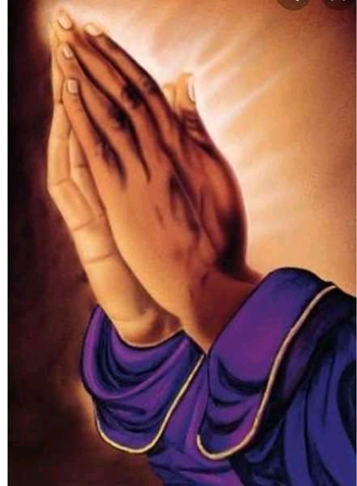CHRISTIANITY IS A RELIGION, LOVING GOD IS AN ATITUDE, BUT MAKING MONEY WITH VIRTUE OF THE RELIGION IS SACARSTIC. DRAW A BOLD LINE BWTWEEN CHRISTIANITY, LOVING GOD, AND RELIGIOUS ENTERPRISE.
- SANCTUS-BALIN

